**Prescription Monitoring Program  
Information Exchange Service**

**Service Conformance**

**Specification**

**Version 1.0**

**October 2012**

Table of Contents

1 Introduction 6

2 Document Purpose 7

3 Conformance Scope 7

4 Conformance Requirements 8

4.1 Conformance Targets 8

4.2 General Conformance Requirements (Normative) 9

4.3 PMIX State-to-Hub Specific Requirements (Normative) 13

4.4 PMIX Hub-to-Hub Specific Requirements (Normative) 14

5 Test Configuration 15

5.1 PMIX State-to-Hub 15

5.1.1 Disclosing Site (RECEIVER) 16

5.1.2 Requesting Site (SENDER) 16

5.2 PMIX Hub-to-Hub 17

5.3 Conformance Test Utilities 18

6 Conformance Test Scenarios 20

6.1 PMIX State-to-Hub 20

6.1.1 T0101: Service Interaction Test - Disclosing 21

6.1.2 T0201: Service Interaction Test - Requesting 25

6.1.3 T0102: Interface Definition Test – Negative - Disclosing 29

6.1.4 T0202: Interface Definition Test – Negative - Requesting 32

6.1.5 T0103: Interface Definition Test – Positive - Disclosing 35

6.1.6 T0203: Interface Definition Test – Positive - Requesting 38

6.1.7 T0104: Interface Definition Test – SOAP Fault - Disclosing 41

6.1.8 T0204: Interface Definition Test – SOAP Fault - Requesting 44

6.2 PMIX Hub-to-Hub 47

6.2.1 T0301: Service Interface Interaction Test 48

6.2.2 T0302: Authorization Test 52

6.2.3 T0303: Required Field Validation Test 56

7 Conformance Report 60

Appendix A: References 64

Appendix B: Conformance Test Preparation Checklist 65

Appendix C: soapUI Test Request / Response Sample Data 66

Requests 66

Responses 67

Appendix D: Document History 68

Appendix E: SCP Guidelines 69

Figures

Figure 1: Conformance Overview 5

Figure 2: PMIX State-to-Hub Disclosing Site Test Process Overview 15

Figure 3: PMIX State-to-Hub Requesting Site Test Process Overview 15

Figure 4: PMIX Hub-to-Hub Test Environment 16

Figure 5: Conformance Test Tool - soapUI Pro Overview 17

Figure 6: Conformance Test Tool - soapUI Pro Automated Reporting 18

Figure 7: Service Interaction Test Environment – Disclosing 20

Figure 8: soapUI: T0101 - Service Interaction Test – Disclosing 23

Figure 9: Service Interaction Test Environment - Requesting 24

Figure 10: soapUI: T0201 - Service Interaction Test – Requesting 27

Figure 11: soapUI: T0102 - Interface Definition Test – Negative - Disclosing 30

Figure 12: soapUI: T0202 - Interface Definition Test - Negative - Requesting 33

Figure 13: soapUI: T0103 - Interface Definition Test - Positive - Disclosing 36

Figure 14: soapUI: T0203 - Interface Definition Test - Positive - Requesting 39

Figure 15: soapUI: T0104 - Interface Definition Test - SOAP Fault - Disclosing 42

Figure 16: soapUI: T0204 - Interface Definition Test - SOAP Fault - Requesting 45

Figure 17: Service Interface Interaction Test Environment 47

Figure 18: soapUI: T0301 – Service Interface Interaction Test 50

Figure 19: Authorization Test Environment 51

Figure 20: soapUI: T0302 – Authorization Test 54

Figure 21: Required Field Validation Test Environment 55

Figure 22: soapUI: T0303 – Required Field Validation Test 58

Figure 23: PMIX Springboard Service Conformance Test - soapUI Report - Overview 59

Figure 24: PMIX Springboard Service Conformance Test - soapUI Report - Results Overview 60

Figure 25: PMIX Springboard Service Conformance Test - soapUI Report - T0101 Results 61

Figure 26: PMIX Springboard Service Conformance Test - soapUI Report - T0102 Results 61

Figure 27: PMIX Springboard Service Conformance Test - soapUI Report - T0103 Results 62

Figure 28: PMIX Springboard Service Conformance Test - soapUI Report - T0104 Results 62

Figure 29: Service Conformance Package (SCP) Structure 68

Tables

Table 1: PMIX SCP Test Suite Conformance Targets 7

Table 2: MESSAGE requirements from PMIX SIDD 8

Table 3: SENDER requirements from PMIX SIDD 9

Table 4: RECEIVER requirements from PMIX SIDD 10

Table 5: Hub requirements from PMIX H2H SIDD 11

Table 6: PMIX State-to-Hub Specific Requirements 12

Table 7: PMIX SSP H2H Specific Requirements 13

Table 8: Requirement - TestCase Matrix 19

Table 9: TestCase - Requirement Matrix 19

Table 10: Test Case T0101 - Requirement Verification 21

Table 11: Test Case T0101 - Assertions 21

Table 12: Test Case T0201 - Requirement Verification 25

Table 13: Test Case T0201 - Assertions 25

Table 14: Test Case T0102 - Requirement Verification 28

Table 15: Test Case T0102 - Assertions 28

Table 16: Test Case T0202 - Requirement Verification 31

Table 17: Test Case T0202 - Assertions 31

Table 18: Test Case T0103 - Requirement Verification 34

Table 19: Test Case T0103 - Assertions 34

Table 20: Test Case T0203 - Requirement Verification 37

Table 21: Test Case T0203 - Assertions 37

Table 22: Test Case T0104 - Requirement Verification 40

Table 23: Test Case T0104 - Assertions 40

Table 24: Test Case T0204 - Requirement Verification 43

Table 25: Test Case T0204 - Assertions 43

Table 26: Requirement - TestCase Matrix 46

Table 27: TestCase - Requirement Matrix 46

Table 28: Test Case T0301 - Requirement Verification 48

Table 29: Test Case T0301 - Assertions 48

Table 30: Test Case T0302 - Requirement Verification 52

Table 31: Test Case T0302 - Assertions 52

Table 32: Test Case T0303 - Requirement Verification 56

Table 33: Test Case T0303 - Assertions 56

Table 34: Sample Requests 65

Table 35: Sample Responses 66

# Introduction

The PMIX Service Conformance Specification document describes the conformance testing required to verify interoperability with the Prescription Monitoring Program Information Exchange (PMIX) Service. The document provides the testing information required for government and industry organizations to engage in the conformance testing process.

The PMIX Service is a functional standard which comprises two Global Reference Architecture Service Specification Packages (SSPs).

Figure : Conformance Overview

1. PMIX_SSP_v_1.0.1 (State-to-Hub)
2. PMIX_H2H_SSP_v_1.0.0 (Hub-to-Hub)

The two PMIX SSPs provide the PMIX functional standards for different aspects of the PMIX information exchange architecture. The PMIX SSP contains the details necessary for State-to-Hub communication as well as State-to-State communication without a hub, while the PMIX Hub-to-Hub (H2H) deals with PMIX Architecture compliant hub interactions.

The Service Conformance Specification document identifies the conformance targets, associated requirements and the related test suite / test cases (with assertions) for both aspects of the PMIX information exchange architecture. As such, government and industry organizations will identify the conformance targets and the test suites applicable to them depending on their role in the PMIX information exchange.

In addition to documenting the conformance targets, requirements and assertions, the Service Conformance Specification also provides guidelines for using the Conformance Test Tool. The Conformance Test Tool, soapUI, is an open-source, cross-platform, web service test application, which provides a number of features that will facilitate the PMIX conformance testing and reporting process. soapUI provides well established test scenarios which issue requests, receive responses, apply assertions and generate fully automated, built-in conformance test reports.

# Document Purpose

The Service Conformance Specification document defines the conformance testing necessary to determine whether a new PMIX system meets the interoperability standards defined in either the PMIX State-to-hub or hub-to-hub service specifications. In order to assist in the conformance validation, this test suite document contains conformance targets, test procedures, utility descriptions and relevant sample data sets. The Service Conformance Specification document provides the guidance necessary to ensure that new systems adhere to the specifications.

# Conformance Scope

The Service Conformance Specification concentrates exclusively on the ***interoperable*** aspects of the service interface specification in order to assert that a participating system conforms to the PMIX Specification. The conformance specification and the associated test cases define a series of tests designed to exercise each interoperability aspect of the specification at least once. The Service Conformance Specification is not intended to address functional aspects of participating PMP systems nor is the test suite designed to verify the robustness or performance of the PMP software. The inclusion of positive and negative PMIX Test Responses as well as single contrasted with multiples responses is intended to verify different aspects of interface interoperability not application functionality.

# Conformance Requirements

This section describes what it means to conform to the PMIX Service Conformance Specification, including the identification and definition of conformance targets, the references to other normative specifications and the designation of specific requirements.

## Conformance Targets

A conformance target is any element or aspect of information sharing architecture whose implementation and/or behavior is constrained by the PMIX SSP. The conformance targets will be constrained by requirements that ensure interoperable implementations.

|  |  |
| --- | --- |
| Target | Description |
| *MESSAGE* | The protocol elements that transport the data envelope, including the serialization of the soap12:Envelope element and all content contained in the Header and Body elements |
| *SENDER* | The ***Requesting*** Site’s software components, which generate request messages according to the PMIX service specification |
| *RECEIVER* | The ***Disclosing*** Site’s software components, which generate response messages according to the PMIX service specification |
| *HUB* | The common software components that perform web service intermediate routing functionality for multiple sites |

Table : PMIX SCP Test Suite Conformance Targets

Therefore, the PMIX Service Conformance Specification only addresses, specifies, and constrains the conformance targets (shown in the table above). Other elements of an information sharing architecture are not addressed, specified or constrained.

To conform to this service specification, an approach to integrating two or more information systems must:

* Identify and implement the entire set of conformance targets listed above (either State-to-hub [MESSAGE, SENDER, RECEIVER] or hub-to-hub [HUB]) in a manner consistent with the definitions contained within the specification.
* Meet all the requirements for each target established in the specification.

## General Conformance Requirements (Normative)

The PMIX Service Specification is based on the RELIABLE SECURE WEB SERVICES SERVICE INTERACTION PROFILE (RS WS-SIP) which leverages the Web services (WS) family of technology standards and, in particular, the Web Services Interoperability Organization (WS-I) Reliable Secure Profile [WS-I RSP] to the extent practical.

A ***MESSAGE*** conforms to the PMIX Service Conformance Specification if:

* The message meets the requirements of the *MESSAGE* conformance targets specified in the **[GRA RS WS-SIP]** profile’s *Message Confidentiality, Message Addressing and Message Definitions Mechanisms* sections.
* The message meets the following requirements from the PMIX (State-to-Hub) Service Interface Description Document (SIDD) - Section 4 “Service Interaction Requirements”:

|  |  |
| --- | --- |
| Simple Message | * XML (NIEM) * SOAP |
| Message Confidentiality | * Transport Layer Security * OASIS Basic Security Profile 1.1  w/XML Encryption, XML Signature |
| Message Addressing | * WS-Addressing |

Table : MESSAGE requirements from PMIX SIDD

* The message conforms to the *National Information Exchange Model* (**[NIEM]**) in which the semantics of the service’s information model match NIEM components.

A ***SENDER*** conforms to the PMIX Service Conformance Specification if:

* A sender meets the requirements of the *SERVICE INTERFACE* conformance targets specified in the **[GRA RS WS-SIP]** profile’s *Service Consumer Authentication, Message Confidentiality, Message Addressing, & Message Exchange Patterns* sections.
* The sender meets the following requirements defined in the PMIX (State-to-Hub) Service Interface Description Document (SIDD) - Section 4 “Service Interaction Requirements”:

|  |  |
| --- | --- |
| Message Exchange Pattern | * Request-Response |
| Message Confidentiality | * Transport Layer Security * OASIS Basic Security Profile 1.1  w/XML Encryption, XML Signature |
| Message Addressing | * WS-Addressing |
| Service Consumer Authorization | * Specific role based “rules” |

Table : SENDER requirements from PMIX SIDD

Note: The ***Requesting*** Site, which is represented by the ***SENDER*** conformance target, is also often referred to as a “Client” or a web service “consumer”.

A ***RECEIVER*** conforms to the PMIX Service Conformance Specification if:

* A receiver meets the requirements of the *SERVICE CONSUMER* conformance targets specified in the **[GRA RS WS-SIP]** profile’s *Service Authentication, Message Confidentiality, Message Addressing, Interface Description Requirements & Message Exchange Patterns* sections.
* The sender meets the following requirements defined in the PMIX (State-to-Hub) Service Interface Description Document (SIDD) - Section 4 “Service Interaction Requirements”:

|  |  |
| --- | --- |
| Message Exchange Pattern | * Request-Response |
| Interface Description | * Web Service Description Language (WSDL) 1.1 |
| Message Confidentiality | * Transport Layer Security * OASIS Basic Security Profile 1.1  w/XML Encryption, XML Signature |
| Message Addressing | * WS-Addressing |
| Service Consumer Authorization | * Specific role based “rules” |

Table : RECEIVER requirements from PMIX SIDD

Note: The ***Disclosing*** Site, which is represented by the ***RECEIVER*** conformance target, is also often referred to as a “Service” or a web service “producer”.

A ***HUB*** conforms to the PMIX Service Conformance Specification if:

* A Hub meets the requirements of the *SERVICE INTERFACE* conformance targets specified in the **[GRA RS WS-SIP]** profile’s *Service Consumer Authentication, Message Confidentiality, Message Addressing, & Message Definitions Mechanisms* sections.
* A Hub meets the following requirements defined in the PMIX Hub-to-Hub (H2H) Service Interface Description Document (SIDD) - Section 4 “Service Interaction Requirements”:

|  |  |
| --- | --- |
| Message Exchange Pattern | * Request-Response |
| Interface Description | * Web Service Description Language (WSDL) 1.1 |
| Message Confidentiality | * Transport Layer Security * OASIS Security Profile 1.1  w/XML Encryption, XML Signature |
| Message Addressing | * WS-Addressing |
| Service Consumer Authorization | * Specific role based “rules” |

Table : Hub requirements from PMIX H2H SIDD

## PMIX State-to-Hub Specific Requirements (Normative)

The following table identifies the PMIX State-to-Hub requirements along with references to the section of the PMIX (***State-to-Hub)*** Service Interface Description Document (S2H SIDD) which contains detailed information about the requirements.

| Requirement  Reference # | Requirement Description  (with conformance target) | Section Reference |
| --- | --- | --- |
|  | Requesting Site ***[SENDER]*** MUST implement software consistent with the Service Interaction Requirements | S2H SIDD 4 |
|  | Disclosing Site ***[RECEIVER]*** MUST implement software consistent with the Service Interaction Requirements | S2H SIDD 4 |
|  | Requesting Site ***[SENDER]*** MUST implement a Request-Response Message Exchange Pattern | S2H SIDD 6 |
|  | Disclosing Site ***[RECEIVER]*** MUST implement a Request-Response Message Exchange Pattern | S2H SIDD 6 |
|  | The request ***[MESSAGE]*** MUST conform to the PMIX NIEM Request Schema | S2H SIDD 7 |
|  | Requesting Site ***[SENDER]*** MUST send only PMIX NIEM Request Schema conformant messages | S2H SIDD 7 |
|  | Disclosing Site ***[RECEIVER]*** MUST be able to receive PMIX NIEM Request Schema conformant messages | S2H SIDD 7 |
|  | The response ***[MESSAGE]*** MUST conform to the PMIX NIEM PMP Prescription Report schema | S2H SIDD 7 |
|  | Disclosing Site ***[RECEIVER]*** MUST return responses that conform to the PMIX NIEM PMP Prescription Report | S2H SIDD 7 |
|  | Requesting Site ***[SENDER]*** MUST be able to receive PMIX NIEM PMP Prescription Report responses | S2H SIDD 7 |
|  | Requesting Site ***[SENDER]*** MUST be able to receive “Negative” (not found) PMIX response messages | S2H SIDD 5 |
|  | Disclosing Site ***[RECEIVER]*** MUST be able to send “Negative” (not found) PMIX response messages | S2H SIDD 5 |
|  | Requesting Site ***[SENDER]*** MUST be able to receive “Positive” PMIX IEPD conformant response messages | S2H SIDD 5 |
|  | Disclosing Site ***[RECEIVER]*** MUST be able to send “Positive” PMIX IEPD conformant response messages | S2H SIDD 5 |
|  | Requesting Site ***[SENDER]*** MUST be able to receive server communicationexceptions via SOAP Faults | S2H SIDD 5 |
|  | Disclosing Site ***[RECEIVER]*** MUST be able to send errors / exceptions via SOAP Faults | S2H SIDD 5 |

Table : PMIX State-to-Hub Specific Requirements

## PMIX Hub-to-Hub Specific Requirements (Normative)

The following table identifies the PMIX Hub-to-Hub conformance tests along with a reference to the section of the specification that contains the requirement details; either the PMIX Hub-to-Hub Service Interface Description Document (H2H SIDD) or the PMIX Execution Context Document (EC).

|  |  |  |
| --- | --- | --- |
| Requirement  Reference # | Requirement Description  (with conformance target) | Section Reference |
| R0401 | ***[HUB]*** MUST implement software consistent with the Hub-to-Hub SIDD Service Interaction Requirements | H2H SIDD 3 |
| R0402 | ***[HUB]*** MUST implement software consistent with the Hub-to-Hub SIDD Interface Description Requirements | H2H SIDD 4 |
| R0403 | ***[HUB]*** MUST implement a Request-Response Message Exchange Pattern consistent with the Hub-to-Hub SIDD | H2H SIDD 5 |
| R0404 | ***[HUB]*** MUST not have **any** access to the unencrypted message payload as described in the Security Section | H2H SIDD 8 |
| R0405 | ***[HUB]*** MUST implement site identity management and authorization consistent with the Execution Context | EC 4 |
| R0406 | ***[HUB]*** MUST implement required field validation and fault handling consistent with the Execution Context | EC 6 |
| R0407 | ***[HUB]*** MUST be able to send errors as SOAP Faults | EC 4,6 |

Table : PMIX SSP H2H Specific Requirements

# Test Configuration

## PMIX State-to-Hub

The PMIX State-to-Hub Testing Configuration consists of two distinct test paradigms for the target PMP System - Disclosing Site (RECEIVER) and Requesting Site (SENDER). The requirements, and thus the related conformance tests, validate the Target PMP System’s capability to function as both a Disclosing Site and a Requesting Site.

The following diagrams (Figures 1 & 2) depict the test environment components; the Conformance Test Utilities and the Conformance Test Target PMP System. In addition, the diagrams introduce test participant roles (Initiative Test Manager and Initiative Certification Participant) and show the relationship between components and test roles. The role references will be used throughout the test procedure sections to indicate task responsibility.

Note: Figures 1 - 3 include the depiction of an Optional PMIX Conformant Hub which is intended to convey the concept that a web service intermediary, such as a conformant hub, does not influence the service contract, bindings or data. While final conformance testing will most likely be conducted in conjunction with a conformant hub, that hub will not impact the service interface; rather the hub will serve as a stateless pass-through intermediate web service router. The pre-conformance test checklist, included in Appendix B, will clearly identify the steps associated with configuring all components, including an optional hub.

### Disclosing Site (RECEIVER)

The following test environment facilitates the verification of the PMIX SSP SIP_WS_1.2 conformance tests for a “Disclosing Site” (RECEIVER).



Figure : PMIX State-to-Hub Disclosing Site Test Process Overview

The Initiative Test Manager will utilize the Conformance Test Utilities to send pre-configured PMIX test requests to the Conformance Test Target PMP System endpoint previously configured by the Initiative Certification Participant.

### Requesting Site (SENDER)

The following test environment facilitates the verification of the PMIX SSP SIP_WS_1.2 conformance tests for a “Requesting Site” (SENDER).



Figure : PMIX State-to-Hub Requesting Site Test Process Overview

The Initiative Certification Participant will configure the Conformance Test Target PMP System (1) to send requests to the Conformance Test Utilities which will be monitored by the Initiative Test Manager.

## PMIX Hub-to-Hub

The PMIX Hub-to-Hub Test Configuration consists of a target hub, an optional conformant support hub and two sets of Conformance Testing Utilities. The test environment facilitates the validation of the PMIX H2H SIP_WS_1.2 as defined in the PMIX H2H SSP.



Figure : PMIX Hub-to-Hub Test Environment

## Conformance Test Utilities

The PMIX Service Conformance Test process uses the soapUI web service test utility to issue requests, receive responses, apply assertions and generate reports. soapUI is an open-source, cross-platform, web service test application, which provides a number of features that will facilitate the PMIX conformance testing and reporting process.

The PMIX Service Conformance Test leverages the following soapUI components:



Figure : Conformance Test Tool - soapUI Pro Overview

1. The **TestSuite** is a collection of TestCases that will be used for grouping conformance tests into logical test units
   1. The **TestCases** are collections of TestSteps that further group TestSteps into Basic, Positive, Negative and Fault Test Cases.
   2. The **TestSteps** are the "building blocks" of the conformance tests in soapUI.
2. The PMIX **MockService** provides service simulation by exposing MockOperations
   1. The ProvidePrescriptionDrugHistory **MockOperation** corresponds to the WSDL Operation of the PMIX Service and the contained MockResponse messages are created from the associated schema.

The PMIX Service Conformance Report leverages the soapUI built-in reporting feature. The following image shows a snippet of a typical soapUI test report:

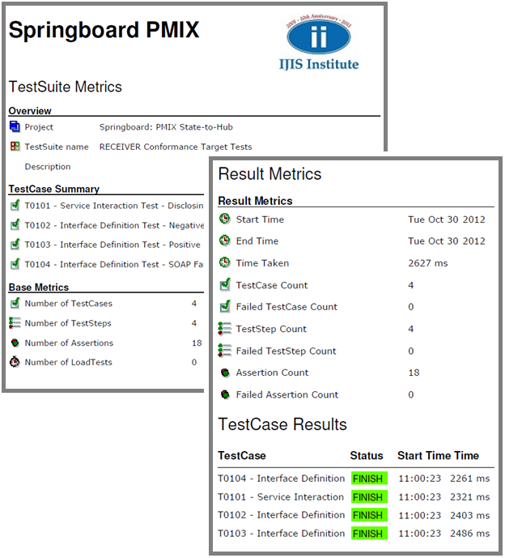

Figure : Conformance Test Tool - soapUI Pro Automated Reporting

# Conformance Test Scenarios

## PMIX State-to-Hub

The following tables establish reference mappings between the Conformance Test Cases and the associated Requirements and vice versa:

| Requirement | TestCases |
| --- | --- |
|  | T0201, T0202, T0203 |
|  | T0101, T0102, T0103 |
|  | T0201, T0202, T0203 |
|  | T0101, T0102, T0103 |
|  | T0203 |
|  | T0203 |
|  | T0103 |
|  | T0103 |
|  | T0103 |
|  | T0203 |
|  | T0202 |
|  | T0102 |
|  | T0203 |
|  | T0103 |
|  | T0204 |
|  | T0104 |

Table : Requirement - TestCase Matrix

|  |  |
| --- | --- |
| TestCase | Requirements |
| T0101 | R0302, R0304 |
| T0102 | R0302, R0304, R0312 |
| T0103 | R0302, R0304, R0307, R0308, R0309, R0314 |
| T0104 | R0316 |
| T0201 | R0301, R0303 |
| T0202 | R0301, R0303, R0311 |
| T0203 | R0301, R0303, R0305, R0306, R0310, R0313 |
| T0204 | R0315 |

Table : TestCase - Requirement Matrix

### T0101: Service Interaction Test - Disclosing

#### Test Overview

The Service Interaction Conformance Test provides the test procedures that ensure conformance to the foundational standards and the request/response message exchange pattern, all from the perspective of the ***disclosing*** site. The test will establish the framework that will be used for all subsequent disclosing site tests, by ensuring that the full communication framework is conformant.



Figure : Service Interaction Test Environment – Disclosing

In the Disclosing Site Service Interaction Conformance Test, the Conformance Test Utility (1) will be used to send a PMIX Request to the Conformance Test Target PMP System’s ProvidePrescriptionDrugHistory operation (2). The Target PMP System must return a PMIX Response message.

#### Test Criteria

The Service Interaction Test’s Conformance Test Target PMP System must be able to successfully receive the PMIX Request and reply with a PMIX Response. The simple test case will verify that the Target PMP System conforms to the core interface protocols and the request/response MEP documented in the PMIX SSP.

Test case **T0101** will be used to verify the following Requirements:

|  |  |
| --- | --- |
| R0302 | Disclosing Site *[RECEIVER]* MUST implement software consistent with the Service Interaction Requirements |
| R0304 | Disclosing Site ***[RECEIVER]*** MUST implement a Request-Response Message Exchange Pattern |

Table : Test Case T0101 - Requirement Verification

Test case **T0101** will use the following assertions to verify conformance:

|  |  |
| --- | --- |
| Assertion Name | Assertion Description |
| SOAP Response | validates that the response is a valid SOAP Response. |
| WS-Addressing Response | validates that the response contains valid WS-Addressing Headers, such as wsa:To and wsa:Action. |
| Valid HTTP Status Codes | checks that the target TestStep received an HTTP result with a status code in the list of defined codes. |

Table : Test Case T0101 - Assertions

#### Test Procedure

Before running the Service Interaction Test (Disclosing), the **Initiative Certification Participant** must:

* bring their PMP System’s Service Interface online,
* ensure that the ProvidePrescriptionDrugHistory operation is available,
* prepare the service to accept an inbound PMIX request message, and
* be ready to send a ProvidePrescriptionDrugHistory PMIX response.

Note: The precise details related to the Initiative Certification Participant’s tasks and, in particular, the PMP System-specific procedural steps are outside the scope of the Service Conformance Specification.

In order to run the Service Interaction Test (Disclosing), the **Initiative Test Manager** must:

* run soapUI,
* open the Springboard: PMIX State-to-Hub project,
* expand the navigator to the “RECEIVER Conformance Target Tests”,
* select the “T0101 - Service Interaction Test - Disclosing” test case and
* open the “Basic Communication - Test Request” test step.
* update the target system URL to reflect the address of the service, and
* run the test step.

The following image provides a reference for the soapUI T0101 TestCase interface:

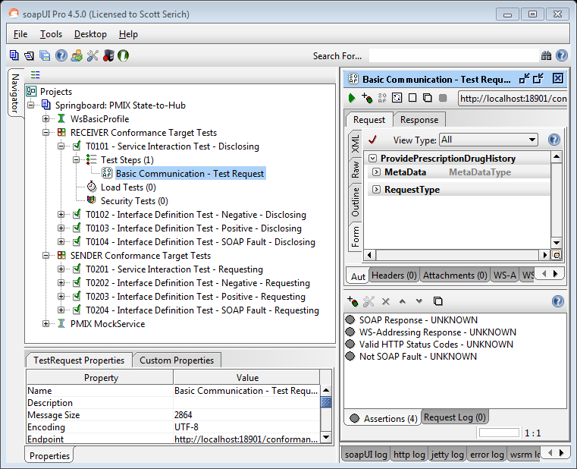

Figure : soapUI: T0101 - Service Interaction Test – Disclosing

When the **TestStep** execution has completed, the **Initiative Test Manager** will review the **Assertions** tab to view and evaluate the conformance test results.

### T0201: Service Interaction Test - Requesting

#### Test Overview

The Service Interaction Conformance Test provides the test procedures that ensure conformance to the foundational standards and the request/response message exchange pattern, all from the perspective of the ***requesting*** site. The test will establish the framework that will be used for all subsequent tests, by ensuring that the full communication foundation is conformant.



Figure : Service Interaction Test Environment - Requesting

In the Requesting Site Service Interaction Conformance Test, the Conformance Test Target PMP System (1) must send a PMIX Request to the Conformance Test Utility (soapUI MockService/MockResponse) ProvidePrescriptionDrugHistory operation (2). The soapUI MockService/MockResponse will return a PMIX Response message to the Target PMP System.

#### Test Criteria

The Service Interaction Test’s Conformance Test Target PMP System must be able to successfully receive a PMIX Request and reply with a PMIX Response. The simple test case will verify that the Target PMP System conforms to the interface standards and the request/response MEP documented in the PMIX SSP.

Test case **T0201** will be used to verify the following Requirements:

|  |  |
| --- | --- |
| R0301 | Requesting Site *[SENDER]* MUST implement software consistent with the Service Interaction Requirements |
| R0303 | Requesting Site ***[SENDER]*** MUST implement a Request-Response Message Exchange Pattern |

Table : Test Case T0201 - Requirement Verification

Test case **T0201** will use the following assertions to verify conformance:

|  |  |
| --- | --- |
| Assertion Name | Assertion Description |
| SOAP Request | validates that the request is a valid SOAP Request. |
| WS-Addressing Request | validates that the request contains valid WS-Addressing Headers, such as wsa:To and wsa:Action. |
| Schema Compliance | validates the request against the PMIX WSDL. |
| Script Assertion | a custom soapUI TestCase script that checks to ensure the request contains the expected element values |

Table : Test Case T0201 - Assertions

#### Test Procedure

In order to support the Service Interaction Test (Requesting), the **Initiative Test Manager** must:

* run soapUI,
* open the Springboard: PMIX State-to-Hub project,
* expand the navigator to the “SENDER Conformance Target Tests”,
* open the “T0201 - Service Interaction Test - Requesting” test case
* select the green arrow icon to start the TestCase

The soapUI TestCase MockResponse TestStep will:

* begin “listening” for requests on the designated interface URL
* be ready to receive inbound request and return configured responses
* update the Assertions according to the overall test case execution

In order to initiate the Service Interaction Test (Requesting), the **Initiative Certification Participant** must:

* configure their PMP System’s Client component(s) to send requests
* establish the correct SOAP Header PMIX Metadata information
* configure the client proxy WS-Addressing To and Action header values
* send the request to the provided target endpoint URL

Note: The precise details related to the Initiative Certification Participant’s tasks and, in particular, the PMP System-specific procedural steps are outside the scope of the Service Conformance Specification.

The following image provides a reference for the soapUI T0201 TestCase interface

TestSuite –> TestCase –> MockResponse TestStep:

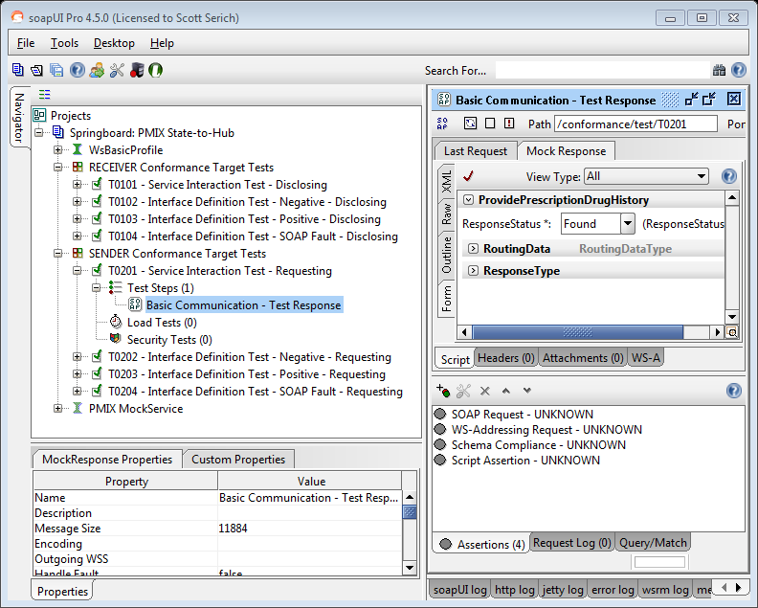

Figure : soapUI: T0201 - Service Interaction Test – Requesting

When the **TestStep** execution has completed, the **Initiative Test Manager** will review the TestStep **Assertions** tab to view and evaluate the conformance test results.

### T0102: Interface Definition Test – Negative - Disclosing

#### Test Overview

The Interface Definition Test provides the test procedures that ensure that the ***disclosing*** site is able to send negative (“Not Found”) responses when there are no matching records corresponding to the incoming request.

#### Test Criteria

Test case **T0102** will be used to verify the following Requirements:

|  |  |
| --- | --- |
| R0302 | Disclosing Site *[RECEIVER]* MUST implement software consistent with the Service Interaction Requirements |
| R0304 | Disclosing Site ***[RECEIVER]*** MUST implement a Request-Response Message Exchange Pattern |
| R0312 | Disclosing Site ***[RECEIVER]*** MUST be able to send “Negative” (not found) PMIX response messages |

Table : Test Case T0102 - Requirement Verification

Test case **T0102** will use the following assertions to verify conformance:

|  |  |
| --- | --- |
| Assertion Name | Assertion Description |
| SOAP Response | validates that the response is a valid SOAP Response. |
| WS-Addressing Response | validates that the response contains valid WS-Addressing Headers, such as wsa:To and wsa:Action. |
| Not SOAP Fault | validates that the response is not a SOAP fault. |
| Schema Compliance | validates the response against the PMIX WSDL. |
| Script Assertion | a custom soapUI TestCase script that checks to ensure the response contains the expected element values |

Table : Test Case T0102 - Assertions

#### Test Procedure

Before running the Interface Definition Negative - Disclosing Test, the **Initiative Certification Participant** must:

* bring their PMP System’s Service Interface online,
* ensure that the ProvidePrescriptionDrugHistory operation is available,
* prepare the service to accept an inbound PMIX request message, and
* be ready to send a ProvidePrescriptionDrugHistory PMIX response.

Note: The precise details related to the Initiative Certification Participant’s tasks and, in particular, the PMP System-specific procedural steps are outside the scope of the Service Conformance Specification.

In order to run the Interface Definition Negative - Disclosing Test, the **Initiative Test Manager** must:

* run soapUI,
* open the Springboard: PMIX State-to-Hub project,
* expand the navigator to the “RECEIVER Conformance Target Tests”,
* select “T0102 - Interface Definition Test - Negative - Disclosing” test case
* open the “Not Found Condition - Test Request” test step,
* update the target system URL to reflect the address of the service, and
* run the test step.

The following image provides a reference for the soapUI T0102 TestCase interface:

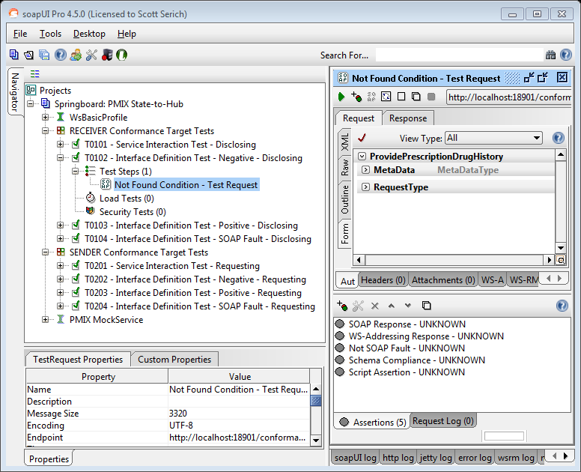

Figure : soapUI: T0102 - Interface Definition Test – Negative - Disclosing

When the **TestStep** execution has completed, the **Initiative Test Manager** will review the TestStep **Assertions** tab to view and evaluate the conformance test results.

### T0202: Interface Definition Test – Negative - Requesting

#### Test Overview

The Interface Definition – Negative - Requesting Test provides the test procedures that ensure that the ***requesting*** site is able to send requests which conform to the PMIX Request schema. In addition, the sender must be able to receive negative (“Not Found”) responses when there are no matching records corresponding to the request.

#### Test Criteria

Test case **T0202** will be used to verify the following Requirements:

|  |  |
| --- | --- |
| R0301 | Requesting Site *[SENDER]* MUST implement software consistent with the Service Interaction Requirements |
| R0303 | Requesting Site ***[SENDER]*** MUST implement a Request-Response Message Exchange Pattern |
| R0311 | Requesting Site ***[SENDER]*** MUST be able to receive “Negative” (not found) PMIX response messages |

Table : Test Case T0202 - Requirement Verification

Test case **T0202** will use the following assertions to verify conformance:

|  |  |
| --- | --- |
| Assertion Name | Assertion Description |
| SOAP Request | validates that the request is a valid SOAP Request. |
| WS-Addressing Request | validates that the request contains valid WS-Addressing Headers, such as wsa:To and wsa:Action. |
| Schema Compliance | validates the request against the PMIX WSDL. |
| Script Assertion | a custom soapUI TestCase script that checks to ensure the request contains the expected element values |

Table : Test Case T0202 - Assertions

#### Test Procedure

In order to support the Interface Definition – Negative - Requesting Test, the **Initiative Test Manager** must:

* run soapUI,
* open the Springboard: PMIX State-to-Hub project,
* expand the navigator to the “SENDER Conformance Target Tests”,
* open “T0202 - Interface Definition Test - Negative - Requesting” test case
* select the green arrow icon to start the TestCase

The soapUI TestCase MockResponse TestStep will:

* begin “listening” for requests on the designated interface URL
* be ready to receive inbound request and return configured responses
* update the Assertions according to the overall test case execution

In order to initiate the Interface Definition – Negative - Requesting Test, the **Initiative Certification Participant** must:

* configure their PMP System’s Client component(s) to send requests
* establish the correct SOAP Header PMIX Metadata information
* configure the client proxy WS-Addressing To and Action header values
* send the request to the provided target endpoint URL

Note: The precise details related to the Initiative Certification Participant’s tasks and, in particular, the PMP System-specific procedural steps are outside the scope of the Service Conformance Specification.

The following image provides a reference for the soapUI T0202 TestCase interface

TestSuite –> TestCase –> MockResponse TestStep:

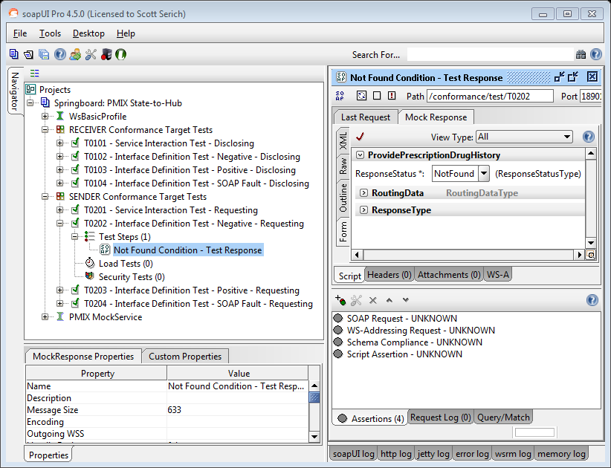

Figure : soapUI: T0202 - Interface Definition Test - Negative - Requesting

### T0103: Interface Definition Test – Positive - Disclosing

#### Test Overview

The Interface Definition - Positive - Disclosing Test provides the test procedures that ensure that the ***disclosing*** site is able to send positive (“Found”) responses when there are matching records for an incoming request.

#### Test Criteria

Test case **T0103** will be used to verify the following Requirements:

|  |  |
| --- | --- |
| R0302 | Disclosing Site *[RECEIVER]* MUST implement software consistent with the Service Interaction Requirements |
| R0304 | Disclosing Site ***[RECEIVER]*** MUST implement a Request-Response Message Exchange Pattern |
| R0307 | Disclosing Site ***[RECEIVER]*** MUST be able to receive PMIX NIEM Request Schema conformant messages |
| R0308 | The response ***[MESSAGE]*** MUST conform to the PMIX NIEM PMP Prescription Report schema |
| R0309 | Disclosing Site ***[RECEIVER]*** MUST return response that conform to the PMIX NIEM PMP Prescription Report |
| R0314 | Disclosing Site ***[RECEIVER]*** MUST be able to send “Positive” PMIX IEPD conformant response messages |

Table : Test Case T0103 - Requirement Verification

Test case **T0103** will use the following assertions to verify conformance:

|  |  |
| --- | --- |
| Assertion Name | Assertion Description |
| SOAP Response | validates that the response is a valid SOAP Response. |
| WS-Addressing Response | validates that the response contains valid WS-Addressing Headers, such as wsa:To and wsa:Action. |
| Not SOAP Fault | validates that the response is not a SOAP fault. |
| Schema Compliance | validates the response against the PMIX WSDL. |
| Script Assertion | a custom soapUI TestCase script that checks to ensure the response contains the expected element values |

Table : Test Case T0103 - Assertions

#### Test Procedure

Before running the Interface Definition Positive - Disclosing Test, the **Initiative Certification Participant** must:

* bring their PMP System’s Service Interface online,
* ensure that the ProvidePrescriptionDrugHistory operation is available,
* prepare the service to accept an inbound PMIX request message, and
* be ready to send a ProvidePrescriptionDrugHistory PMIX response.

Note: The precise details related to the Initiative Certification Participant’s tasks and, in particular, the PMP System-specific procedural steps are outside the scope of the Service Conformance Specification.

In order to run the Interface Definition Positive - Disclosing Test, the **Initiative Test Manager** must:

* run soapUI,
* open the Springboard: PMIX State-to-Hub project,
* expand the navigator to the “RECEIVER Conformance Target Tests”,
* select “T0103 - Interface Definition Test - Positive - Disclosing” test case
* open the “ProvidePrescriptionDrugHistory -2 Hits - Test Request” test step,
* update the target system URL to reflect the address of the service, and
* run the test step.

The following image provides a reference for the soapUI T0103 TestCase interface: 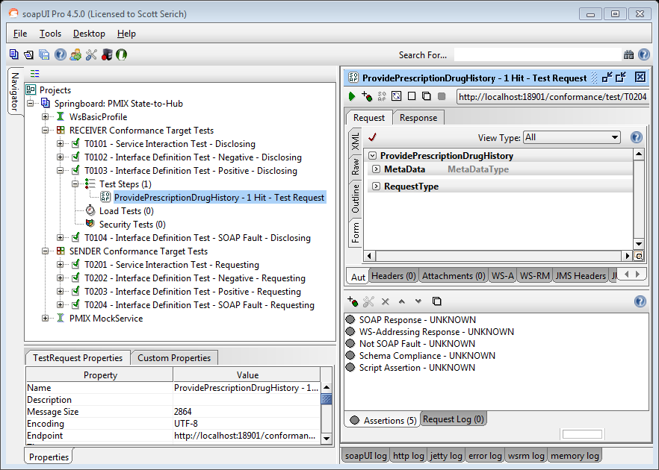

Figure : soapUI: T0103 - Interface Definition Test - Positive - Disclosing

When the **TestStep** execution has completed, the **Initiative Test Manager** will review the TestStep **Assertions** tab to view and evaluate the conformance test results.

### T0203: Interface Definition Test – Positive - Requesting

#### Test Overview

The Interface Definition - Positive - Requesting Test provides the test procedures that ensure that the ***requesting*** site is able to send requests which conform to the PMIX Request schema. In addition, the sender must be able to receive positive (“Found”) responses which contain one or more prescription records.

#### Test Criteria

Test case **T0203** will be used to verify the following Requirements:

|  |  |
| --- | --- |
| R0301 | Requesting Site *[SENDER]* MUST implement software consistent with the Service Interaction Requirements |
| R0303 | Requesting Site ***[SENDER]*** MUST implement a Request-Response Message Exchange Pattern |
| R0305 | The request ***[MESSAGE]*** MUST conform to the PMIX NIEM Request Schema |
| R0306 | Requesting Site ***[SENDER]*** MUST send only PMIX NIEM Request Schema conformant messages |
| R0310 | Requesting Site ***[SENDER]*** MUST be able to receive PMIX NIEM PMP Prescription Report responses |
| R0313 | Requesting Site ***[SENDER]*** MUST be able to receive “Positive” PMIX IEPD conformant response messages |

Table : Test Case T0203 - Requirement Verification

Test case **T0203** will use the following assertions to verify conformance:

|  |  |
| --- | --- |
| Assertion Name | Assertion Description |
| SOAP Request | validates that the request is a valid SOAP Request. |
| WS-Addressing Request | validates that the request contains valid WS-Addressing Headers, such as wsa:To and wsa:Action. |
| Schema Compliance | validates the request against the PMIX WSDL. |
| Script Assertion | a custom soapUI TestCase script that checks to ensure the request contains the expected element values |

Table : Test Case T0203 - Assertions

#### Test Procedure

In order to support the Interface Definition - Positive - Requesting Test, the **Initiative Test Manager** must:

* run soapUI,
* open the Springboard: PMIX State-to-Hub project,
* expand the navigator to the “SENDER Conformance Target Tests”,
* open “T0203 - Interface Definition Test - Positive - Requesting” test case
* select the green arrow icon to start the TestCase

The soapUI TestCase MockResponse TestStep will:

* begin “listening” for requests on the designated interface URL
* be ready to receive inbound request and return configured responses
* update the Assertions according to the overall test case execution

In order to initiate the Interface Definition - Positive - Requesting Test, the **Initiative Certification Participant** must:

* configure their PMP System’s Client component(s) to send requests
* establish the correct SOAP Header PMIX Metadata information
* configure the client proxy WS-Addressing To and Action header values
* send the request to the provided target endpoint URL

Note: The precise details related to the Initiative Certification Participant’s tasks and, in particular, the PMP System-specific procedural steps are outside the scope of the Service Conformance Specification.

The following image provides a reference for the soapUI T0203 TestCase interface

TestSuite –> TestCase –> MockResponse TestStep:

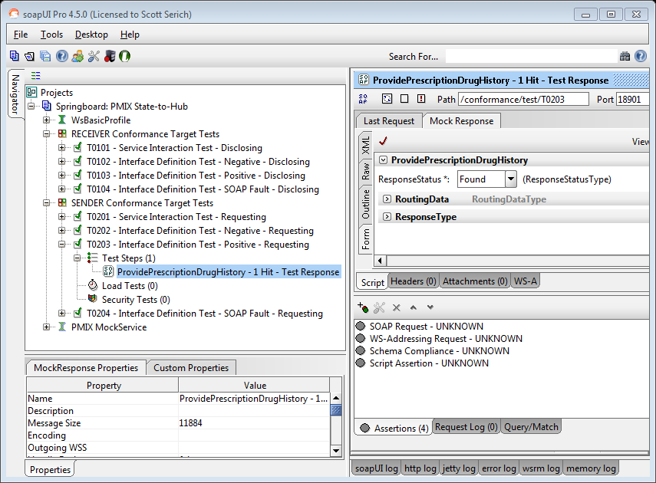

Figure : soapUI: T0203 - Interface Definition Test - Positive - Requesting

When the **TestStep** execution has completed, the **Initiative Test Manager** will review the TestStep **Assertions** tab to view and evaluate the conformance test results.

### T0104: Interface Definition Test – SOAP Fault - Disclosing

#### Test Overview

The Interface Definition - SOAP Fault - Disclosing Test provides the test procedures that ensure that the ***disclosing*** site is able to send SOAP Faults when the incoming SOAP request contains invalid information, such as missing fields in the request payload or incorrect information in the header metadata.

#### Test Criteria

Test case **T0104** will be used to verify the following Requirements:

|  |  |
| --- | --- |
| R0316 | Disclosing Site *[RECEIVER]* MUST be able to send errors / exceptions via SOAP Faults |

Table : Test Case T0104 - Requirement Verification

Test case **T0104** will use the following assertions to verify conformance:

|  |  |
| --- | --- |
| Assertion Name | Assertion Description |
| SOAP Response | validates that the response is a valid SOAP Response. |
| WS-Addressing Response | validates that the response contains valid WS-Addressing Headers, such as wsa:To and wsa:Action. |
| SOAP Fault | validates that the response is a valid SOAP fault. |
| Schema Compliance | validates the response against the PMIX WSDL. |

Table : Test Case T0104 - Assertions

#### Test Procedure

Before running the Interface Definition Test - SOAP Fault - Disclosing, the **Initiative Certification Participant** must:

* bring their PMP System’s Service Interface online,
* ensure that the ProvidePrescriptionDrugHistory operation is available,
* prepare the service to accept an inbound PMIX request message, and
* be ready to send a ProvidePrescriptionDrugHistory PMIX response.

Note: The precise details related to the Initiative Certification Participant’s tasks and, in particular, the PMP System-specific procedural steps are outside the scope of the Service Conformance Specification.

In order to run the Interface Definition Test - SOAP Fault - Disclosing, the **Initiative Test Manager** must:

* run soapUI,
* open the Springboard: PMIX State-to-Hub project,
* expand the navigator to the “RECEIVER Conformance Target Tests”,
* select “T0104 - Interface Definition Test - SOAP Fault - Disclosing” test case
* open the “Invalid Requesting State - Test Request” test step,
* update the target system URL to reflect the address of the service, and
* run the test step.

The following image provides a reference for the soapUI T0104 TestCase interface:

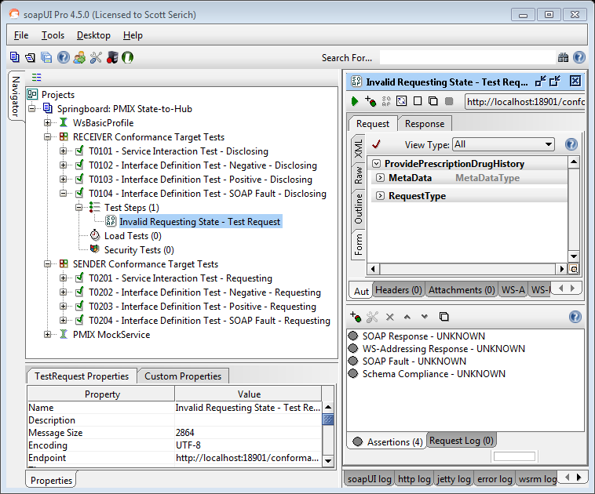

Figure : soapUI: T0104 - Interface Definition Test - SOAP Fault - Disclosing

When the **TestStep** execution has completed, the **Initiative Test Manager** will review the TestStep **Assertions** tab to view and evaluate the conformance test results.

### T0204: Interface Definition Test – SOAP Fault - Requesting

#### Test Overview

The Interface Definition Test - SOAP Fault - Requesting Test provides the test procedures that ensure that the ***Requesting*** site is able to receive SOAP Faults when there is invalid information in the incoming SOAP request, such as missing fields in the request payload or incorrect information in the header metadata.

#### Test Criteria

Test case **T0204** will be used to verify the following Requirements:

|  |  |
| --- | --- |
| R0315 | Requesting Site *[SENDER]* MUST be able to receive server communication exceptions via SOAP Faults |

Table : Test Case T0204 - Requirement Verification

Test case **T0204** will use the following assertions to verify conformance:

|  |  |
| --- | --- |
| Assertion Name | Assertion Description |
| SOAP Request | validates that the request is a valid SOAP Request. |
| WS-Addressing Request | validates that the request contains valid WS-Addressing Headers, such as wsa:To and wsa:Action. |

Table : Test Case T0204 - Assertions

#### Test Procedure

In order to support the Interface Definition Test - SOAP Fault - Requesting Test, the **Initiative Test Manager** must:

* run soapUI,
* open the Springboard: PMIX State-to-Hub project,
* expand the navigator to the “SENDER Conformance Target Tests”,
* open “T0204 - Interface Definition Test - SOAP Fault - Requesting” test case
* select the green arrow icon to start the TestCase

The soapUI TestCase MockResponse TestStep will:

* begin “listening” for requests on the designated interface URL
* be ready to receive inbound request and return configured responses
* update the Assertions according to the overall test case execution

In order to initiate the Interface Definition Test - SOAP Fault - Requesting Test, the **Initiative Certification Participant** must:

* configure their PMP System’s Client component(s) to send requests
* establish the correct SOAP Header PMIX Metadata information
* configure the client proxy WS-Addressing To and Action header values
* send the request to the provided target endpoint URL

Note: The precise details related to the Initiative Certification Participant’s tasks and, in particular, the PMP System-specific procedural steps are outside the scope of the Service Conformance Specification.

The following image provides a reference for the soapUI T0204 TestCase interface

TestSuite –> TestCase –> MockResponse TestStep:

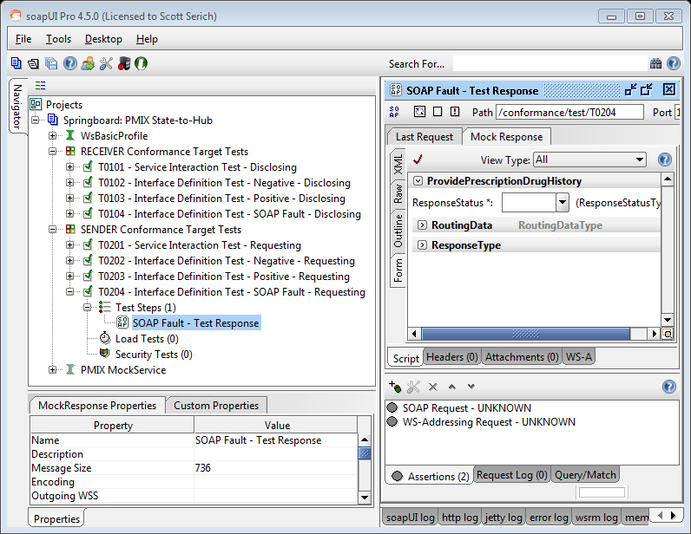

Figure : soapUI: T0204 - Interface Definition Test - SOAP Fault - Requesting

When the **TestStep** execution has completed, the **Initiative Test Manager** will review the TestStep **Assertions** tab to view and evaluate the conformance test results.

## PMIX Hub-to-Hub

The following tables establish reference mappings between the Conformance Test Cases and the associated Requirements and vice versa:

| Requirement | TestCases |
| --- | --- |
|  | T0301 |
|  | T0301 |
|  | T0301 |
|  | T0301 |
|  | T0302 |
|  | T0303 |
|  | T0302, T0303 |

Table : Requirement - TestCase Matrix

|  |  |
| --- | --- |
| TestCase | Requirements |
| T0301 | R0401, R0402, R0403 R0404 |
| T0302 | R0405, R0407 |
| T0303 | R0406, R0407 |

Table : TestCase - Requirement Matrix

### T0301: Service Interface Interaction Test

#### Test Overview

The Service Interface Interaction Conformance Test provides the procedures necessary to ensure conformance to the Service Interaction Requirements, the Interface Definition and the standard request/response message exchange pattern. The test will establish the framework that will be used for all subsequent tests, by ensuring that the full communication foundation, from the Test Utilities is conformant.



Figure : Service Interface Interaction Test Environment

In the Hub Service Interface Interaction Conformance Test, the Conformance Test Utility (1) Request Form will be used to send a PMIX Request to another Conformance Test Utility MockService ProvidePrescriptionDrugHistory operation (2) through the Conformance Test Target Hub System’s (2). Optionally, a PMIX Conformant Hub can be introduced into the data flow path for further Hub-to-Hub validation. Test results will be gathered and the corresponding reporting will be generated from the Conformance Test Utility Request perspective (1).

#### Test Criteria

Test case **T0301** will be used to verify the following Requirements:

|  |  |
| --- | --- |
| R0401 | *[HUB]* MUST implement software consistent with the Hub-to-Hub SIDD Service Interaction Requirements |
| R0402 | ***[HUB]*** MUST implement software consistent with the Hub-to-Hub SIDD Interface Description Requirements |
| R0403 | ***[HUB]*** MUST implement a Request-Response Message Exchange Pattern consistent with the Hub-to-Hub SIDD |
| R0404 | ***[HUB]*** MUST not have any access to the unencrypted message payload as described in the Security Section |
| R0405 | ***[HUB]*** MUST implement site identity management and authorization consistent with the Execution Context (*) |
| R0406 | ***[HUB]*** MUST implement required field validation and fault handling consistent with the Execution Context (*) |

Table : Test Case T0301 - Requirement Verification

Note (*): Test T0301 will validate the positive conditions for requirements R0405 and R0406, since the message origin and destination must both be configured properly and the message has all the required fields.

Test case **T0301** will use the following assertions to verify conformance:

|  |  |
| --- | --- |
| Assertion Name | Assertion Description |
| SOAP Response | validates that the response is a valid SOAP Response. |
| WS-Addressing Response | validates that the response contains valid WS-Addressing Headers, such as wsa:To and wsa:Action. |
| Not SOAP Fault | validates that the response is not a SOAP fault. |
| Schema Compliance | validates the response against the PMIX WSDL. |
| Valid HTTP Status Codes | checks that the target TestStep received an HTTP result with a status code in the list of defined codes. |
| Encrypted Data | A manually applied assertion that must verify the message payload is encrypted throughout the hub processing. The assertion may be applied via network capture, application logging and/or code walkthrough/review. |

Table : Test Case T0301 - Assertions

#### Test Procedure

In order to support the Service Interface Interaction Test, the **Initiative Test Manager** must:

* run soapUI,
* open the Springboard: PMIX Hub-to-Hub project,
* expand the navigator to the “PMIX MockService”,
* open the MockService Editor
* select the green arrow icon to start the MockService

The soapUI MockService will:

* begin “listening” for requests on the designated interface URL
* respond to inbound requests with the corresponding response

In order to prepare for the Service Interface Interaction Test, the **Initiative Certification Participant** must:

* bring their Hub’s Host Service Interface online,
* prepare the service to accept an inbound PMIX request message
* configure their Hub’s Client component(s) to send requests
* send the request to the provided target endpoint URL

Note: The precise details related to the Initiative Certification Participant’s tasks and, in particular, the PMP System-specific procedural steps are outside the scope of the Service Conformance Specification.

In order to run the Service Interface Interaction Test, the **Initiative Test Manager** must:

* run soapUI,
* open the Springboard: PMIX Hub-to-Hub project,
* expand the navigator to the “HUB Conformance Target Tests”,
* select “T0301 - Service Interaction Test” test case
* open the “Basic Communication - Test Request” test step,
* update the target system URL to reflect the address of the service, and
* run the test step.

The following image provides a reference for the soapUI T0301 TestCase interface:

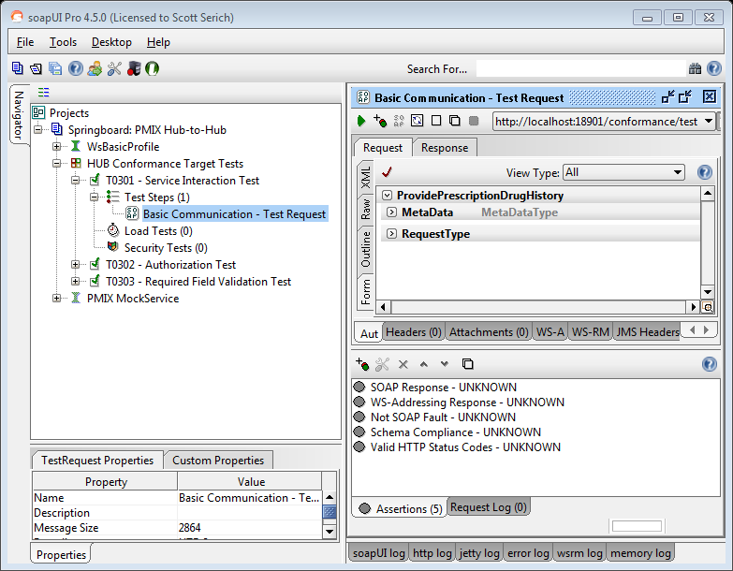

Figure : soapUI: T0301 – Service Interface Interaction Test

When the **TestStep** execution has completed, the **Initiative Test Manager** will review the TestStep **Assertions** tab to view and evaluate the conformance test results.

### T0302: Authorization Test

#### Test Overview

A conformant hub must perform two authorizations for each message processed:

**Verify the requesting state role is authorized to send messages**

The hub verifies that the requesting state role can send messages to the disclosing state by referring to the ‘Sender Roles’ directory. The ‘Sender Roles’ directory contains a list of roles. For each role, there is a list of authorized destination states that the role can send messages to. The hub validates a message if the destination state is one of these authorized states.

**Verify the disclosing state is authorized to receive messages**

The hub verifies that the disclosing state can receive messages from a role by referring to the ‘Authorized Sites’ directory. This directory contains a list of states. For each state, there is a list of authorized roles from which messages can be accepted. The hub validates a message if the requesting state role is one of these authorized roles.



Figure : Authorization Test Environment

In the Hub Authorization Conformance Test, the Conformance Test Utility (1) Request Form will be used to send a PMIX Request to the Conformance Test Target Hub which must throw an authorization error in a SOAP Fault message back to the sender. In order to test the various aspects of hub authorization, the soapUI test case will have multiple test steps; invalid role, unauthorized requesting state and unauthorized disclosing state.

#### Test Criteria

Test case **T0302** will be used to verify the following Requirements:

|  |  |
| --- | --- |
| R0405 | *[HUB]* MUST implement site identity management and authorization consistent with the Execution Context |
| R0407 | ***[HUB]*** MUST be able to send errors as SOAP Faults |

Table : Test Case T0302 - Requirement Verification

Test case **T0302** will use the following assertions to verify conformance:

|  |  |
| --- | --- |
| Assertion Name | Assertion Description |
| SOAP Response | validates that the response is a valid SOAP Response. |
| SOAP Fault | validates that the response is a valid SOAP fault. |
| Schema Compliance | validates the response against the PMIX WSDL. |

Table : Test Case T0302 - Assertions

#### Test Procedure

In order to support the Authorization Test, the **Initiative Test Manager** must:

* run soapUI,
* open the Springboard: PMIX Hub-to-Hub project,
* expand the navigator to the “PMIX MockService”,
* open the MockService Editor
* select the green arrow icon to start the MockService

The soapUI MockService will:

* begin “listening” for requests on the designated interface URL
* respond to inbound requests with the corresponding response

In order to prepare for the Authorization Test, the **Initiative Certification Participant** must:

* bring their Hub’s Host Service Interface online,
* prepare the service to accept an inbound PMIX request message
* configure their Hub’s Client component(s) to send requests
* send the request to the provided target endpoint URL

Note: The precise details related to the Initiative Certification Participant’s tasks and, in particular, the PMP System-specific procedural steps are outside the scope of the Service Conformance Specification.

In order to run the Interface Authorization Test, the **Initiative Test Manager** must:

* run soapUI,
* open the Springboard: PMIX Hub-to-Hub project
* expand the navigator to the “HUB Conformance Target Tests”
* select “T0302 - Authorization Test” test case
* open the “Unauthorized Role - Test Request” test step
* update the target system URL to reflect the address of the service
* open the “Unauthorized Requesting State - Test Request” test step
* update the target system URL to reflect the address of the service
* open the “Unauthorized Disclosing State - Test Request” test step
* update the target system URL to reflect the address of the service
* open the TestCase Editor and click the green arrow to run the test case

The following image provides a reference for the soapUI T0302 TestCase interface:

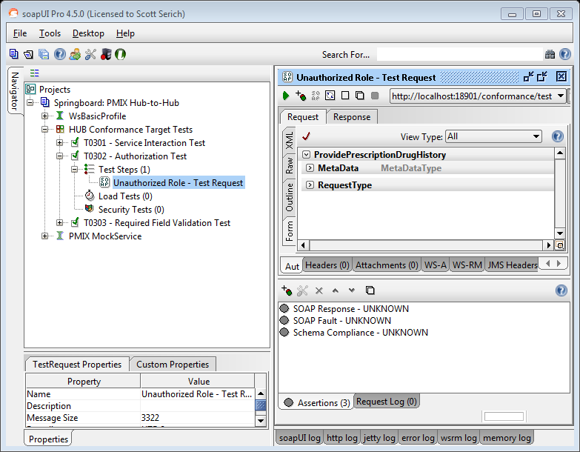

Figure : soapUI: T0302 – Authorization Test

When the **TestStep** execution has completed, the **Initiative Test Manager** will review the TestStep **Assertions** tab to view and evaluate the conformance test results.

### T0303: Required Field Validation Test

#### Test Overview

A conformant hub must implement the required PMIX request required field validation, such that all PMIX intermediaries are able to access the global site request parameter requirements and compare the rules against the metadata associated with the in-transit message.



Figure : Required Field Validation Test Environment

A conformant hub must be able to access the global set of site request parameter requirements stored in the distributed LDAP directory service as request profiles. Each request profile will identify a unique set of request parameters that establish the minimum inquiry data for the request. The hub will then need to apply the request profiles to the messages during the intermediary routing process.

In the Hub Required Field Validation Conformance Test, the Conformance Test Utility (1) Request Form will be used to send a PMIX Request to the Conformance Test Target Hub which must throw a required field validation error in a SOAP Fault message back to the sender.

#### Test Criteria

Test case **T0303** will be used to verify the following Requirements:

|  |  |
| --- | --- |
| R0406 | *[HUB]* MUST implement required field validation and fault handling consistent with the Execution Context |
| R0407 | ***[HUB]*** MUST be able to send errors as SOAP Faults |

Table : Test Case T0303 - Requirement Verification

Test case **T0303** will use the following assertions to verify conformance:

|  |  |
| --- | --- |
| Assertion Name | Assertion Description |
| SOAP Response | validates that the response is a valid SOAP Response. |
| SOAP Fault | validates that the response is a valid SOAP fault. |
| Schema Compliance | validates the response against the PMIX WSDL. |

Table : Test Case T0303 - Assertions

#### Test Procedure

In order to support the Required Field Validation Test, the **Initiative Test Manager** must:

* run soapUI,
* open the Springboard: PMIX Hub-to-Hub project,
* expand the navigator to the “PMIX MockService”,
* open the MockService Editor
* select the green arrow icon to start the MockService

The soapUI MockService will:

* begin “listening” for requests on the designated interface URL
* respond to inbound requests with the corresponding response

In order to prepare for the Required Field Validation Test, the **Initiative Certification Participant** must:

* bring their Hub’s Host Service Interface online,
* prepare the service to accept an inbound PMIX request message
* configure their Hub’s Client component(s) to send requests
* send the request to the provided target endpoint URL

Note: The precise details related to the Initiative Certification Participant’s tasks and, in particular, the PMP System-specific procedural steps are outside the scope of the Service Conformance Specification.

In order to run the Required Field Validation Test, the **Initiative Test Manager** must:

* run soapUI,
* open the Springboard: PMIX Hub-to-Hub project,
* expand the navigator to the “HUB Conformance Target Tests”,
* select “T0303 - Required Field Validation Test” test case
* open the “Missing Last Name - Test Request” test step,
* update the target system URL to reflect the address of the service, and
* run the test step.

The following image provides a reference for the soapUI T0303 TestCase interface:

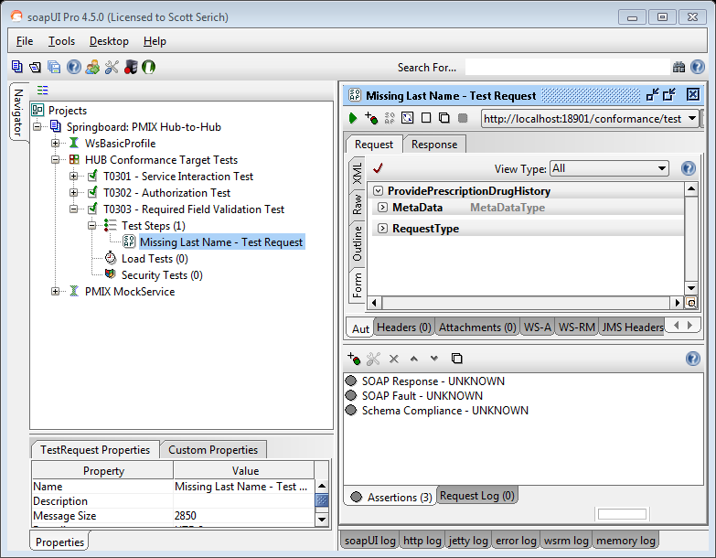

Figure : soapUI: T0303 – Required Field Validation Test

When the **TestStep** execution has completed, the **Initiative Test Manager** will review the TestStep **Assertions** tab to view and evaluate the conformance test results.

# Conformance Report

The following screen images depict snippets of the soapUI customized PMIX Springboard Service Conformance Report.

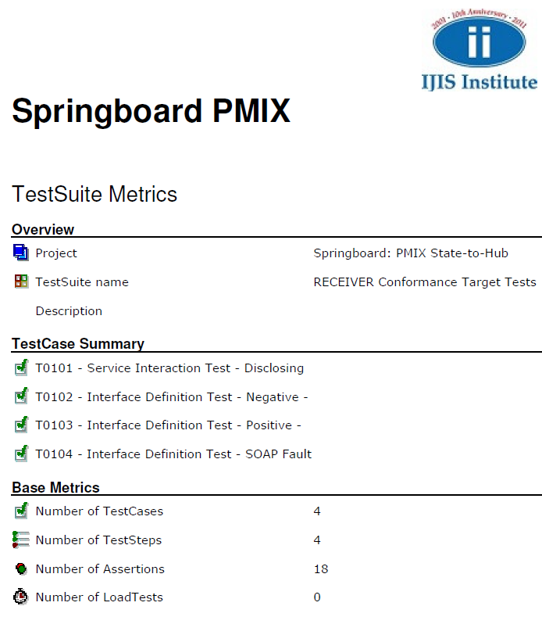

Figure : PMIX Springboard Service Conformance Test - soapUI Report - Overview

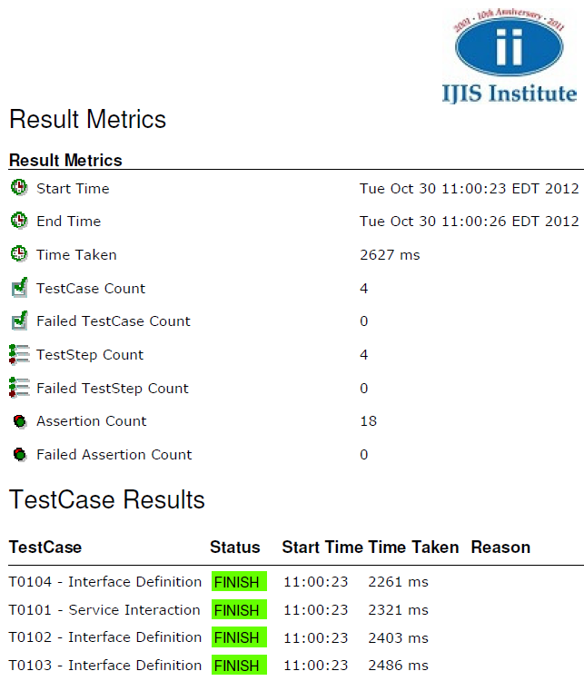

Figure : PMIX Springboard Service Conformance Test - soapUI Report - Results Overview

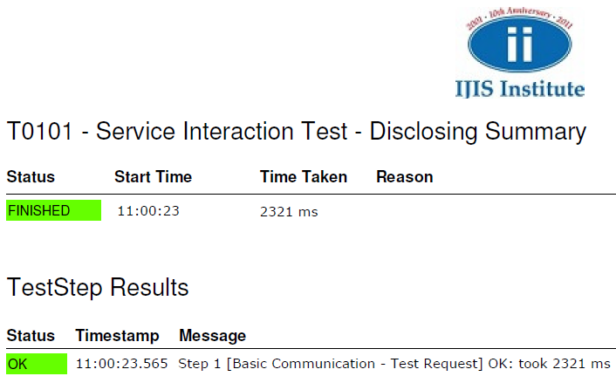

Figure : PMIX Springboard Service Conformance Test - soapUI Report - T0101 Results

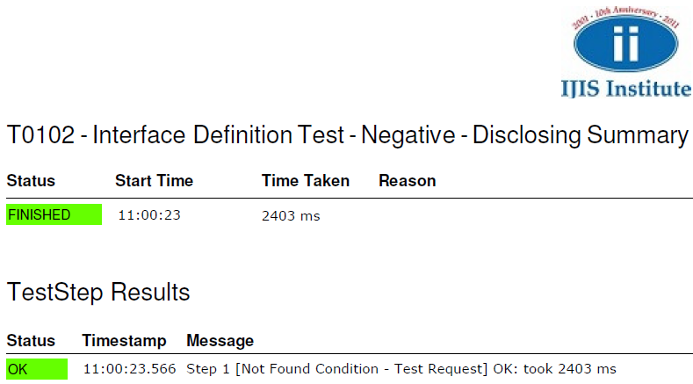

Figure : PMIX Springboard Service Conformance Test - soapUI Report - T0102 Results

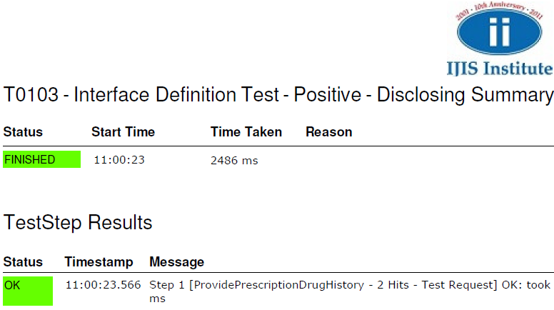

Figure : PMIX Springboard Service Conformance Test - soapUI Report - T0103 Results

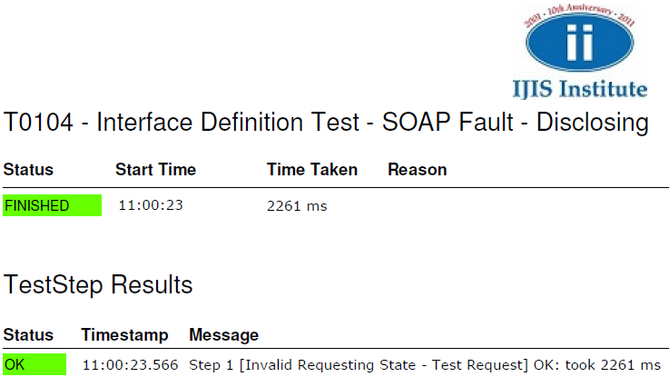

Figure : PMIX Springboard Service Conformance Test - soapUI Report - T0104 Results

# Appendix A: References

* PMIX (State-to-Hub) Service Interface Description Document (SIDD) V1.0.1, June 2012
* PMIX Hub-to-Hub Service Interface Description Document (SIDD) V1.0.0, April 2012
* PMIX State-to-Hub Service Specification Package, v1.0.1 - PMIX_SSP_v_1.0.1
  + <http://www.pmpalliance.org/pdf/20111227%20PMIX_SSP_v_1.0.1.zip>
* PMIX Hub-to-Hub Service Specification Package, v1.0.0 - PMIX_Hub-to-Hub_SSP_v_1.0.0
  + <http://www.pmpalliance.org/pdf/PMIX_H2H_SSP_v_1.0.0.zip>
* PMIX Execution Context v 1.0
  + [http://www.pmpalliance.org/pdf/PMIX Execution Context v1.0 April 2012.pdf](http://www.pmpalliance.org/pdf/PMIX%20Execution%20Context%20v1.0%20April%202012.pdf)

# Appendix B: Conformance Test Preparation Checklist

**Network**

* Configure firewall to allow inbound service requests
* Enable outbound routing to the target test system
* Configure DNS entry for target system
* Optional: Enable network capture to assist with any setup issues

**Certificate**

* Configure the conformance test candidate site certificate with public & private keys
* Export and distribute the local system’s x.509 certificate with public key
* Obtain and import the target test system x.509 certificate with public key

**Application**

* Service
  + Update PMP system with the proper service site code
  + Enable PMP service to listen for inbound test requests
  + Setup test data set to provide response to test requests
    - Test Case T0101 requires data from Appendix C: Response: 1
    - Test Case T0102 requires a simple “Not Found” response
    - Test Case T0103 requires data from Appendix C: Response: 6
    - Test Case T0104 requires a simple “SOAP Fault” response
* Client
  + Update PMP system with the proper client/target system site code
  + Prepare PMP client to send outbound test requests
    - Test Case T0201 requires data from Appendix C: Request: 1
    - Test Case T0202 requires data from Appendix C: Request: 4
    - Test Case T0203 requires data from Appendix C: Request: 6
    - Test Case T0204 requires data from Appendix C: Request: 9
  + Optional: Enable application tracing to assist with any setup issues

**Reference**

* soapUI (<http://www.soapui.org/>)
  + soapUI is a free and open source cross-platform web service testing solution
  + automated functional, regression, compliance and load tests along with reporting

# Appendix C: soapUI Test Request / Response Sample Data

The tables below summarize the relevant request and response data that will be used by the Conformance Test Tools to support PMIX State-to-Hub and Hub-to-Hub test scenarios. The summary data not only contains the field value pairs required for official conformance testing, but also includes records that identify supplemental test cases, which can be used for additional functional testing.

Requests

The following table contains a list of request data records used by the supported test scenarios:

|  |  |  |  |  |  |  |  |
| --- | --- | --- | --- | --- | --- | --- | --- |
| # | LastName | FirstName | DOB | SSN | Sex | Search Range | Response(s) |
| 1 | Doe | John | 1946-05-04 | 123-12-1230 | M | 2012-02-10 -  2012-02-20 | 1 |
| 2 | Doe | John |  | 123-12-1230 |  | 2012-02-10 -  2012-02-30 | 1 & 2 |
| 3 | Doe | John | 1946-05-04 |  |  | 2012-02-10 -  2012-03-30 | 1, 2 & 3 |
| 4 | Doe | Jane | 1956-01-19 | 234-12-2340 | F | 2012-02-10 -  2012-02-30 | - |
| 5 | Doe | Jane | 1956-01-19 |  |  | 2012-04-01 -  2012-04-30 | 4 & 5 |
| 6 | Murphy | George |  | 372-24-8382 | M | 2012-01-01 -  2012-01-30 | 6 & 7 |
| 7 | Murphy | George |  |  |  | 2012-01-01 -  2012-01-30 | 6, 7 & 8 |
| 8 | Murphy | George | 1960-02-16 |  |  | 2012-01-01 -  2012-01-30 | - |
| 9 | Smith | Melissa | 1977-03-31 | 432-44-2313 | F | 2012-02-01 -  2012-04-30 | 9, 10 |
| 10 | Smith | Melissa | 1977-03-31 | 432-44-2313 |  | 2012-01-01 -  2012-01-30 | - |

Table : Sample Requests

Note: The “Response(s)” column in Table 34: “Sample Requests” links test request inquiry data to the corresponding test response(s) outlined in Table 34: “Sample Responses”. In order to simulate real request/response transaction scenarios, the Conformance Test Utilities are configured to receive the above requests and reply with the designated response(s).

Responses

The following table contains a list of response data records used by the supported test scenarios:

|  |  |  |  |  |  |  |
| --- | --- | --- | --- | --- | --- | --- |
| # | LastName | FirstName | DOB | SSN | Sex | Rx Date |
| 1 | Doe | John | 1946-05-04 | 123-12-1230 | M | 2012-02-13 |
| 2 | Doe | John | 1946-05-04 | 123-12-1230 | M | 2012-02-26 |
| 3 | Doe | John | 1946-05-04 | 123-12-1230 | M | 2012-03-23 |
| 4 | Doe | Jane | 1956-01-19 | 234-12-2340 | F | 2012-04-03 |
| 5 | Doe | Jane | 1956-01-19 | 234-12-2340 | F | 2012-04-07 |
| 6 | Murphy | George | 1980-02-16 | 372-24-8382 | M | 2012-01-17 |
| 7 | Murphy | George | 1970-02-16 | 372-24-8382 | M | 2012-01-27 |
| 8 | Murphy | George | 1980-02-16 | 540-24-8685 | M | 2012-01-20 |
| 9 | Smith | Melissa | 1977-03-31 | 432-44-2313 | F | 2012-02-12 |
| 10 | Smith | Melissa | 1977-03-31 | 432-44-2313 | F | 2012-04-12 |

Table : Sample Responses

A ProvidePrescriptionDrugHistory request specifies some search criteria. The records that meet these requirements are sent back in the ResponseData in the response message. In case there are no matching records, the ResponseData is empty.

# Appendix D: Document History

|  |  |  |  |
| --- | --- | --- | --- |
| Date | Version | Editor | Change |
| 10/25/2012 | 1.0 | Todd Seymour, Open Networks | Initial Service Conformance Specification release |
|  |  |  |  |
|  |  |  |  |
|  |  |  |  |
|  |  |  |  |

# Appendix E: SCP Guidelines

The Service Conformance Package (SCP) consists of document artifacts, mockup service test data, model conformance reports and supporting test applications/utilities. The SCP should be organized according to the following directory structure.



Figure : Service Conformance Package (SCP) Structure

The Service Conformance Specification document describes the conformance testing required to verify service interoperability. The following outline provides a summary of the Service Conformance Specification document structure and contents:

1. Introduction
2. Document Purpose
3. Conformance Scope
4. Conformance Requirements
5. Test Configuration
6. Conformance Test Scenarios
7. Conformance Report

The Service Conformance Specification document identifies the conformance targets, associated requirements and the related test suite / test cases (with assertions) for both aspects of the PMIX information exchange architecture.